Day 2 Article 2 《中国家庭的新成员》

Activity 1

- Circle the character 养in this paragraph.
- How many times is 养used in this paragraph? ____
养宠物的历史已经有很久了。几千年以前，人们就开始养猴子、小猫、小狗、小鸟等等。最近几年，越来越多的中国人开始养宠物了，还把宠物
当成家庭新成员。为什么现在的中国人这么喜欢养宠物呢？

- 你还可以养什么？

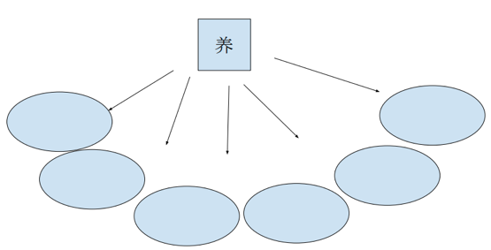

Activity 2

- Circle the words: 以前and 最近
养宠物的历史已经有很久了。几千年以前，人们就开始养猴子、小猫、小狗、小鸟等等。最近几年，越来越多的中国人开始养宠物了，还把宠物
当成家庭新成员。为什么现在的中国人这么喜欢养宠物呢？

- Fill the phrases along with the two words, and also the sentence following the two words:
_______以前， ______________________
最近____________, ____________________

- Find the key sentence in the first paragraph.

Activity 3

- Read aloud the second paragraph in your group.
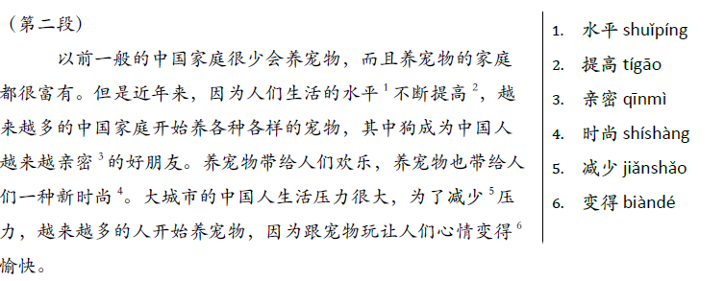
- Answer the following two questions
- 在中国哪种宠物越来越受欢迎？
- 养宠物对大城市生活的人有什么帮助？
Activity 4

Work together in your group to complete this chart based on the second paragraph.

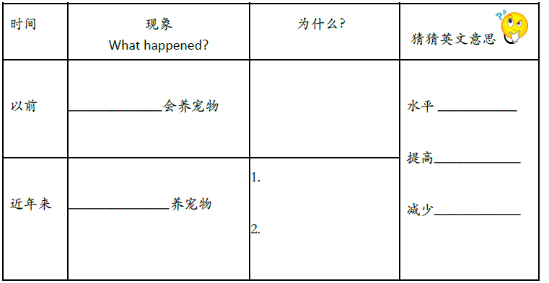

Activity 5

Work together in your group to complete this summary of the second paragraph.

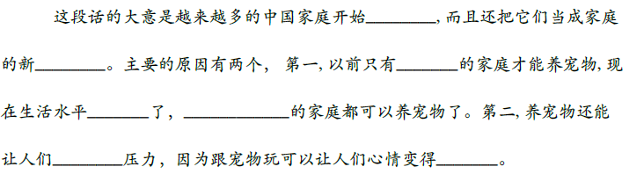

Activity 6

Analogy exercise:
